**Odisha Police UI Testing**

Home page > **In Odia** > convert description of know your police station

Convert all these to odia

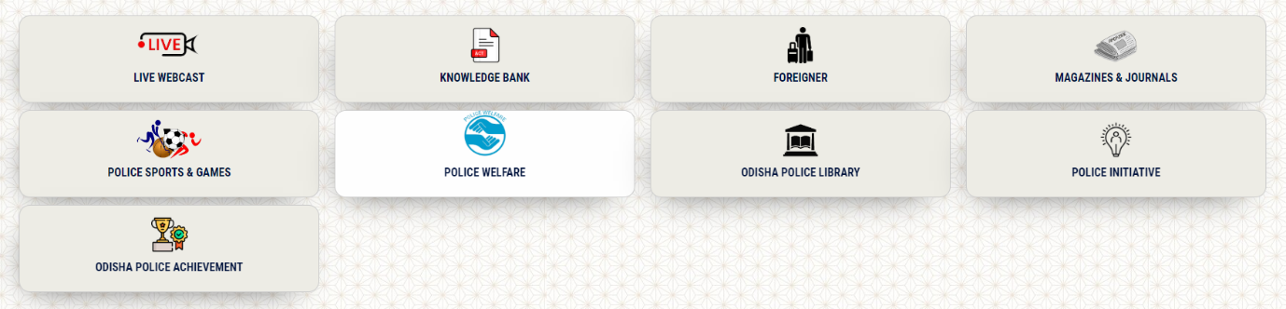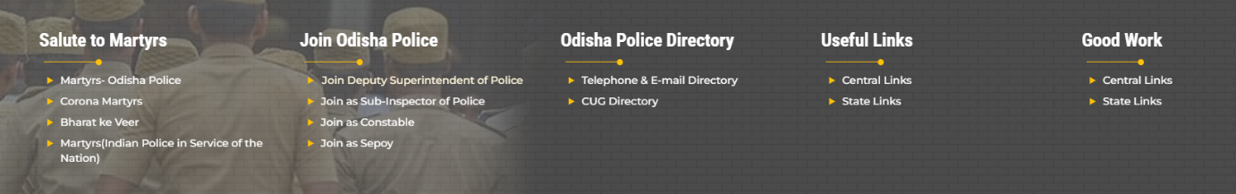

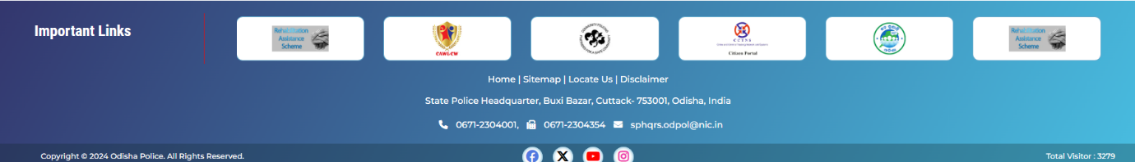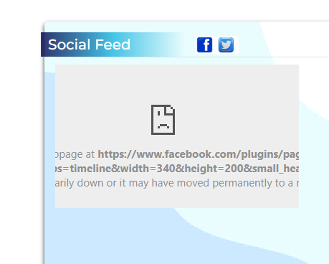

Non Desined Page ( In Odia)

<https://mtpl.work/odisha-police/od/sun/page/police-ranks--badges>

<https://mtpl.work/odisha-police/od/sun/page/odisha-police-museum>

<https://mtpl.work/odisha-police/od/sun/page/seniority-list>

<https://mtpl.work/odisha-police/od/sun/page/forms-relating-to-employee>

Error desined Page ( in odia)

<https://mtpl.work/odisha-police/od/sun/govt-orders>

In admission> submission of PAR(2pages), e-dispatch(2pages)

In citizen portal

<https://citizenportal-op.gov.in/Citizen/InvalidRequest.aspx> (not working)

<https://mtpl.work/odisha-police/en/sun/safety-tips> ( no content)

<https://mtpl.work/odisha-police/en/sun/page/police-grievance> (no content)

<https://mtpl.work/odisha-police/en/sun/road-safety-tips> (no content)

https://mtpl.work/odisha-police/en/sun/subpage/29/arakhi ( 404 error)

Rti

<https://mtpl.work/odisha-police/en/sun/rti> ( pdf – after clicking – 404 error)

Link not given

